Greencomet document

# Create Project

An in-person Tasker needs to have a space to be told how much money they need to have on them to complete the task. If you are creating a task to pick up dry cleaning, for example, there needs to a space to tell the tasker how much money they need to take with them. An Estimate.  
  
If a person is selecting hourly task, there needs to be a line that allows the task creator to estimate the number of hours per week. This of course can change, but the task creator needs to be required to give this estimate.

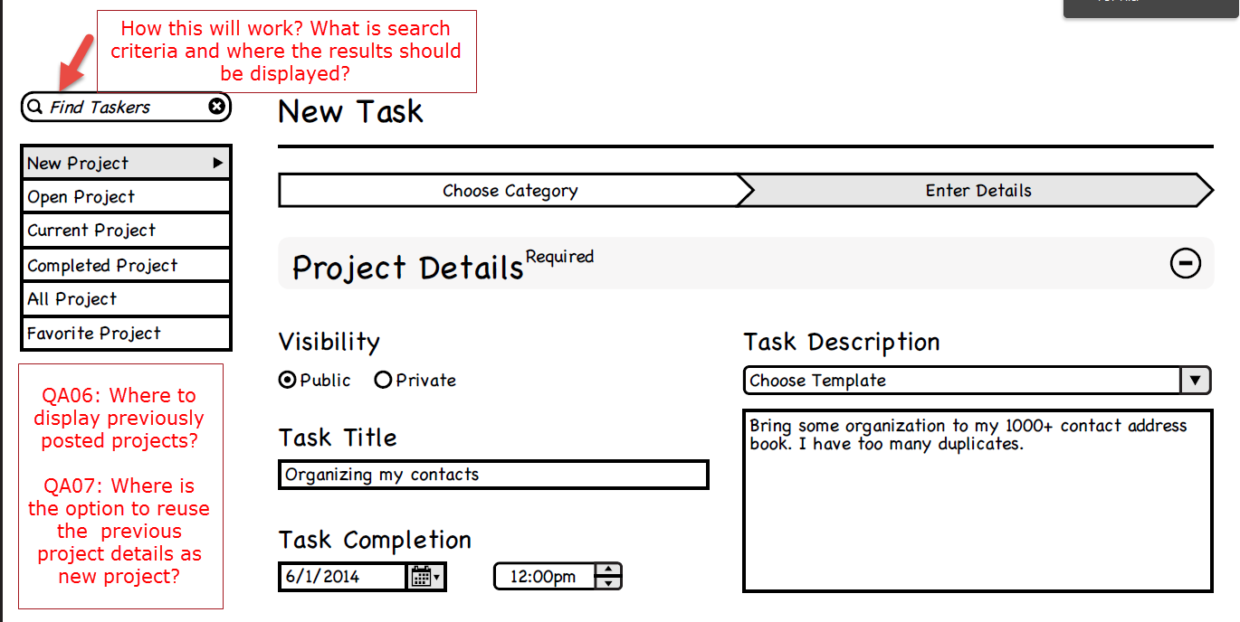

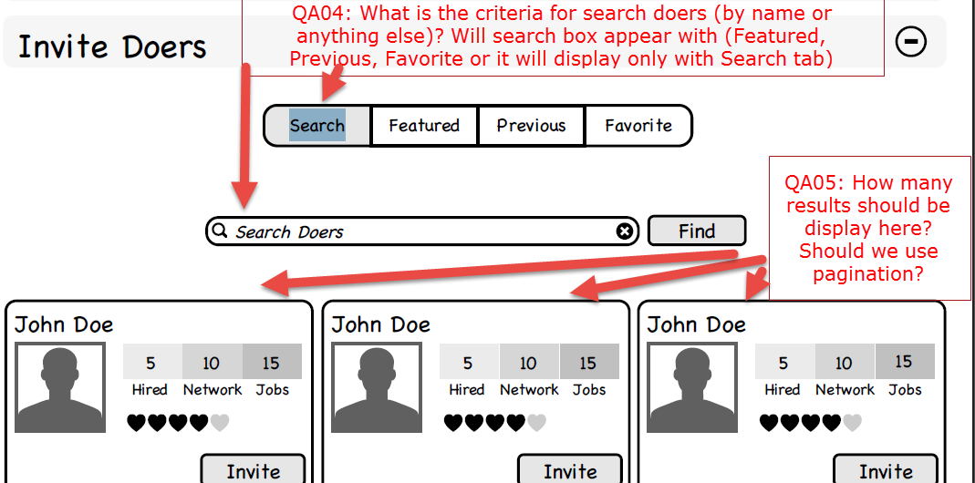

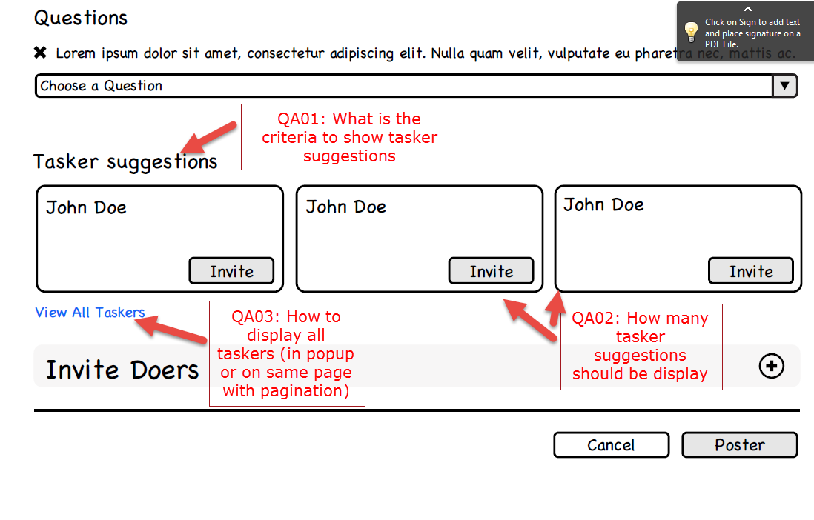

Answers to queries:

•         Find Taskers – results will show on the Search for Taskers results screen. If a search query is initiated, the page will change to the search for taskers results.

•         QA06: This is Matthew’s question to answer. He is in charge of visual design.

•         QA07: This is Matthew’s question to answer. He is in charge of visual design.

•         QA04: search result criteria should be:

1.       Premium members who have worked for is before (who were given a positive rating – 4 start or more) by us … then…

2.       Taskers who are premium members who have the same skills as the task in their profile … then…

3.       Basic/Regular membership Taskers we have worked with before whom we awarded a positive rating …then…

4.       Taskers who have 5 heart rating who have the same skills as the task in their profile… then…

5.       Taskers who have 4 heart rating who have the sane skills as the task in their profile… then…

6.       Random taskers.

•         QA05: 3 results. Do not show pagination. Instead, use scroll arrows like we did with the categories. They can click the arrow and the result on the edge rolls off the screen while a new result rolls on to the screen. Does this make sense?

•         QA01, QA02, QA03: **those are from an old Wireframe**. Those are now the same as the QA05 and QA05 – they are the same thing. Suggest a tasker and invite Doer are the same thing, just from different versions of the same page. Please see the latest version of the wireframe – version 7.

Brad (2014-04-25)

Search field on sidebar is based on which tab you're on (that whole bar is based on context). If a Doer is on the Doer tab then it searches jobs. If a poster is on the poster tab then it searches post. It takes the user to the search page once they begin to search.

QA06: These are left off because I don't think the user needs to see previously posted projects while adding a new project. In the contextual sidebar there is an option for viewing all previous projects which a poster can click at any time.

QA07: We can add this in the new project section under project details if this is a confirmed featured wanted. It makes more sense there. I thought we had decided this wasn't needed and we we'ere going with the template for descriptions?

QA05: No pagination. The wireframe is setup to show 3 across on each row. Just left and right arrows since we have confined space here.

QA01: This is an old screen. This is under invite Doers accordion now. I think you've combined two different screens (old and new) here.

Hope this answers any questions you may have.

Matthew

**QA11: If Featured tab is selected then doers only from featured list having doer name as input in search box would be searched and likewise for other tabs. Is this correct?**

**QA12: If poster selects Search tab then following rule will follow.**

**1.   Premium members who have worked for is before (who were given a positive rating - 4 start or more) by us … then…**

**2.   Taskers who are premium members who have the same skills as the task in their profile … then…**

**3.   Basic/Regular membership Taskers we have worked with before whom we awarded a positive rating …then…**

**4.   Taskers who have 5 heart rating who have the same skills as the task in their profile… then…**

**5.   Taskers who have 4 heart rating who have the sane skills as the task in their profile… then…**

**6.   Random taskers.**

**QA13: If taskers in above 5 criterias is not found than only point 6 work. Is this correct or there is any other process for search.**

**Please confirm.**

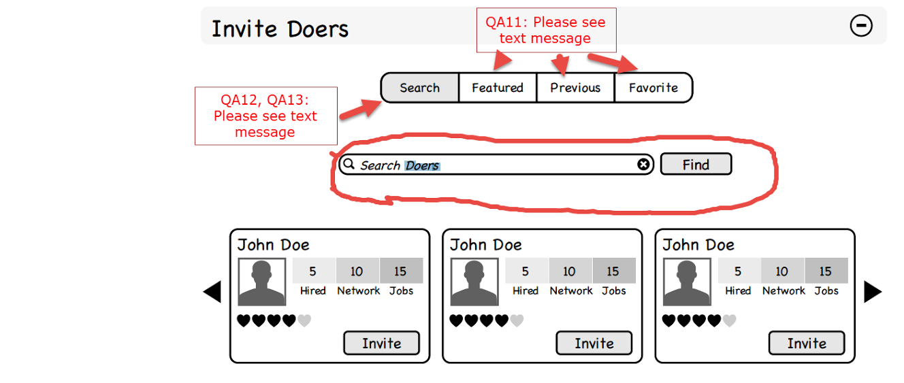

Here are some answers to your queries, and some more detail that hopefully make good sense.

**QA11:** Here is the order you display results in each of the tabs.

If Featured Tab:

1.       Taskers who are premium members with the same skills as the task in their profile … then…

2.       Premium Taskers who have 5 heart rating who have the same skills as the task in their profile… then…

3.       Premium Taskers who have 4 heart rating who have the sane skills as the task in their profile… then…

4.       Random premium tasker.

Favorite Tab:

1.       Taskers who we have worked with before who are on our favorites list… then…

2.       Premium Taskers from our favorites who have the same skills as the task in their profile… then …

3.       Taskers from our favorites list who have the same skills as the task in their profile… then…

4.       Random Taskers from our favorites list.

Previous Tab:

1.       Premium members who have worked for us before who were given a positive rating – (*4 heart or more*)… then…

2.       Basic/Regular membership Taskers we have worked with before whom we awarded a positive rating …then…

3.       Random previous taskers.

**QA12:** Here is the order for search results:

1.       Taskers who are premium members and have the same skills as the task in their profile… then…

2.       Taskers who have 5 heart rating and have the same skills as the task in their profile… then…

3.       Taskers who have 4 heart rating and  have the sane skills as the task in their profile… then…

4.       Any random premium member, no matter what skills they have listed… then…

5.       Any random member with a rating of 3 or above

**QA13:** Correct.

Brad (2014-04-28)

# Edit Projet by Poster

Poster can edit task up to someone bids on it. (2014-04-20)

If they are in the screen editing it, while it is live and someone bids on it, they won’t be able to finish the editing. It will have been too late. (2014-04-20)

# Complete Project

 They have to complete the rating before they hit the ‘complete’ button.

If they hit the complete button before leaving a rating, then they get a roadblock on their screen that tells them the benefits (and penalty) for not leaving a rating. The roadblock should have the rating inputs on it so they don’t have to “go back” they can complete the rating on the Roadblock (a pop-up, or a lightbox). (2014-04-21)

The bonus only goes on the very last invoice – when the task is complete, but not weekly.

If the receipt is not approved, The poster should probably have a pop-up/lightbox that gives them choices for why not approved (radio buttons with choices – too much money, not from my project, not delivered, not ordered etc). Then, the poster moves on and completes the transaction, paying the portions that they do agree to. What we do next, if the Doer is upset by not being reimbursed for the receipt (if they don’t feel the denial is legit), they can appeal to our Dispute Resolution team.

Would you use this tasker again should also be five stars and should be averaged into the overall rating. The question should say – how likely are you to work with this person again? We want to have this be part of the overall user rating.

I like it better with the receipts in this accounting area. Show them where the money is going by line item. You might even put the fee in here. Show them where the money is going.

# Rating

My thinking would be you would have an automatically generated messaged (which would get tagged under payment) suggested a user please leave a rating.

# Release Payment

1.       The contextual sidebar needs to be the same as the other wireframes pages we have been working on.

a.       Title of the task moves from the header, to the ‘top of the right section’

b.      Contextual sidebar dominates the left of the page.

2.       Each account needs to have a ‘nickname’. If they are saving this for future use, it needs to be labeled. An input to name the account is very useful.

3.       If its PayPal, it needs to switch over to PayPal inputs (not account number, rather should be email and password.

4.       FOR SIMPLICITY – I like the way Elance has an account set up page, and then, when you are funding a task, you chose which account you want, but you don’t have the inputs on that screen. What this does is makes it very simple to chose the account to use. Its really just a fancy drop down. (2014-04-21)

# Weekly Invoice

We need to have a weekly invoice. Maybe it is generated automatically?

-          The Doer gets a message on ‘payday’ that tells them to put their hours in and attach their work. It could go right to their inbox/discussion forum with inputs instead of a free text paragraph field.

-          The Poster gets the message and any attachments, then releases the funds from the escrow. (2014-04-18)

# Settings

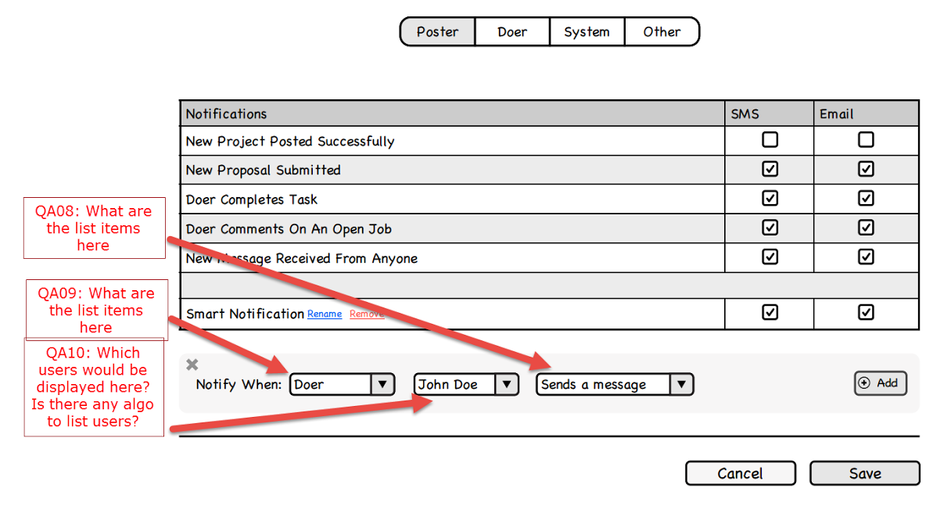

QA08: This is a list that we are going to want to be add to in the future. This is a very powerful feature. To start with for now, let’s use these choices:

1.       Sends a Message*(NOTE: only when they send a message to us, not when they send a message to just anyone).*

2.       Posts a Task

3.       Accepts a Task

4.       Completes a Task

QA09: Matthew – do we need this choice – if we just have them select the user they want to get notifications about, they could be posting and Doing tasks. What we really want is to be able to know an update when a user we are interested in does something. They might be both kinds of users, right?

QA10:  Only users who are connected to us in our network. We want to only allow the option of receiving updates on users we are mutually connected with.

Brad (2014-04-28)